• Purity Assessment:
Obtain a very sensitve measure of the purity of your sample. Sedimentation velocity experiments can detect small amounts of impurities in your sample, and identify conformational heterogeneity, as well as molecular weight heterogeneity. A combination of sedimentation velocity and sedimentation equilibrium experiments can assist in distinguishing between the two

• Mutation Effects:
By making mutations to your sample, you may be able to effect changes in sample characteristics that may be monitored by analytical ultracentrifugation. These changes may affect binding, self-assocition, molecular weight, function and conformation. AUC serves as an important analytical tool to asses these changes.

• Molecular Weight Determination:
For pure samples and paucidisperse samples of two or three discrete components it is possible to obtain molecular weights, as well as limited shape information, such as frictional coefficients, diffusion coefficients and model axial ratios for hypothetical models such as prolate and oblate ellipsoids, long rods and spheres (Stokes radii).

• Binding Stoichiometry:
For well separated ligand/substrate systems it may be possible to determine binding stoichiometries for the individual components. If different chromophores exist, it may be possible to separate the signal of ligand and substrate to sufficiently to observe bound and unbound species separately.

• Self-Association behavior:
For self-associating systems it is often possible to determine a monomer molecular weight, the extent of oligomerization and the strength of the association, and to obtain quantitative measures for the association and dissociation constants. This type of experiment is often used to assess the effect of one or more mutations on a putative binding region and the resulting binding strength.

• Conformational Changes and Effects:
For many systems the conformational state of a molecule is of interest. You may be interested if buffer conditions (salt, pH, etc), temperature, or even mutations have an effect on the conformation of the sample, or function of the sample, as it is related to conformation.

Here is a short list of the types of scientific questions that can be answered with Analytical Ultracentrifugation:
- Is my sample homogeneous or heterogeneous?
- Does my sample self-associate?
- Do I have aggregation?
- What molecular weight is my sample?
- Does my sample bind to the ligand?
- What is the stoichiometry of binding?
- Are there conformational changes resulting from different buffer/temperature conditions (salt, pH, ligand concentration, etc)?
- Do the mutations I have designed affect the strength of binding, self-association, conformation, stoichiometry, etc.?
- Is my sample suitable (pure enough) for X-ray crystallography, NMR?
- How does my multi-enzyme complex associate? What are the steps and are there intermediates?
- What overall shape does my sample have?
- What is my sample's sedimentation or diffusion coefficient?
- What is the Stoke's radius of my sample?
- I have a mixture of two (three) proteins, one has a different chromophore (for example, a heme group), how is this protein behaving by itself?
- How does salt affect the concentration dependency (concentration dependent nonideality) of my sample?
- Is the heterogeneity in S due to molecular weight, isomeric shape effects, or both?
Analytical ultracentrifugation has been used successfully on many biological and synthetic systems, here is partial list:
- systems with molecular weights between a few hundred daltons all the way up to many million daltons
- proteins (incl. small peptides, glycosylated proteins, membrane proteins, micelles)
- nucleic acids (single stranded, double stranded, supercoiled, nucleotides and nucleotide analogs)
- whole virus particles
- interacting systems
- synthetic molecules (latex beads, synthetic polymers, etc)
- polysaccharides
- protein-D(R)NA binding, protein-protein binding
- active enzyme-substrate systems

Sedimentation Velocity Experiments

Sedimentation velocity experiments are performed at high speed to overcome the effect of diffusion. Sedimentation will separate the components in the sample providing a very sensitive assay for composition. In a velocity experiment the speed is generally so great that back diffusion from the bottom of the cell is minimal compared to the rate of sedimentation such that a moving boundary will form, behind which will be little to no material left. The evolution of the shape of the boundary over time is representative of the composition, sedimentation and diffusion properties of the sample and in ideal cases can be analyzed for molecular weight.
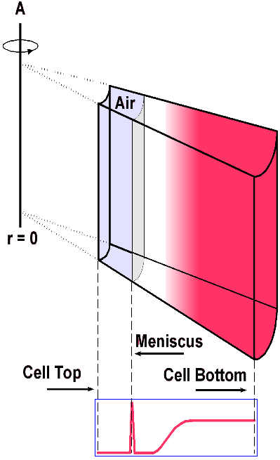
Velocity experiment: a moving boundary is generated because the rotor speed is large enough to prevent back diffusion from the cell bottom to influence the absorbance near the meniscus, which will deplete over time.

Sedimentation equilibrium is a technique where the sample is spun at lower rotor speeds than in a velocity experiment. The sample will simultaneously sediment and back-diffuse from the bottom of the cell and produce a gradient, which will not change once equilibrium is obtained. As soon as equilibrium has been obtained, net flow of material in the cell will cease and sedimentation and diffusion will balance each other. The curvature of the gradient can be influenced by varying the rotor speed, and multiple gradients obtained at different speeds can be used to globally fit the data to a model. While not very sensitive for the detection of heterogeneity (velocity analysis is better suited), equilibrium experiments provide molecular weight with superior accuracy for pauci-disperse systems and can provide thermodynamic information such as binding strength for reversible hetero- or self-associating systems. Sedimentation equilibrium analysis is the method of choice when determining if and at which concentration a protein will dimerize.
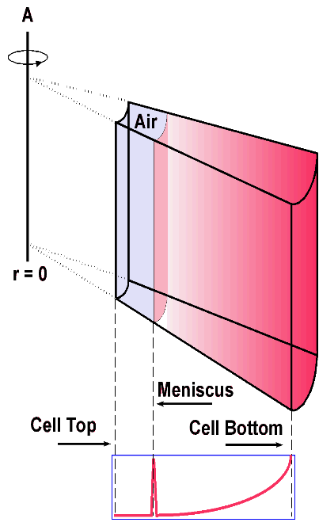
Equilibrium Experiment: the rotor speed is slow enough such that the back diffusion at the bottom of the cell will balance out the sedimentation and form an equilibrium gradient.

